Lab No. 06
Import necessary python libraries & Acquire "fortune500" dataset and perform primitive dataset investigation
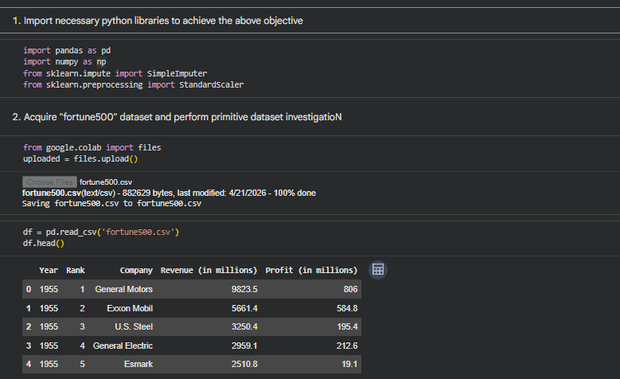

Manage Dataset Attributes
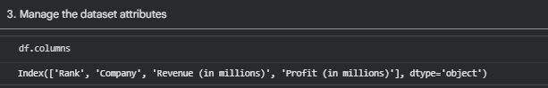
Delete Duplicate Instances from Dataset
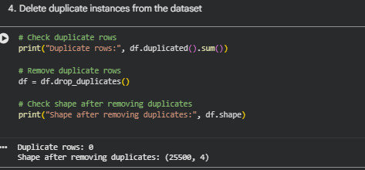

Delete Irrelevant Dataset Features

Determine Missing Values in Dataset
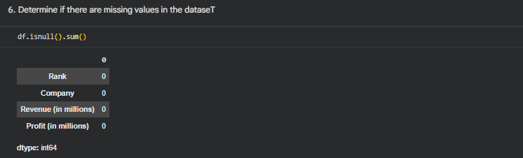
Handle Missing Values
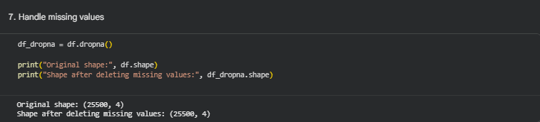

7(b). Fill Missing Values with Zero
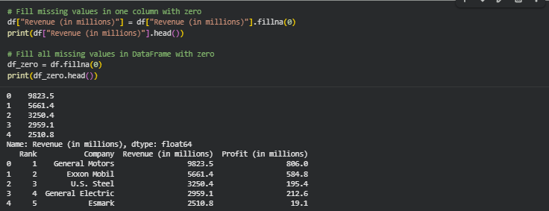
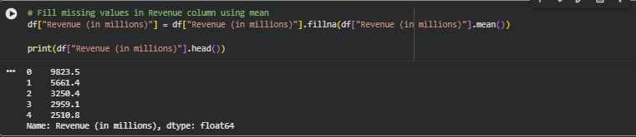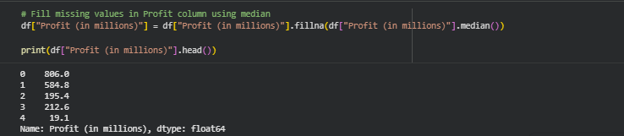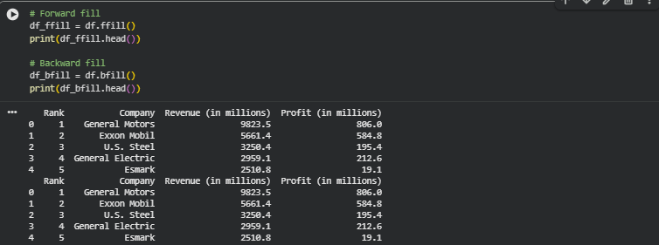
Handle Missing Values Using SimpleImputer
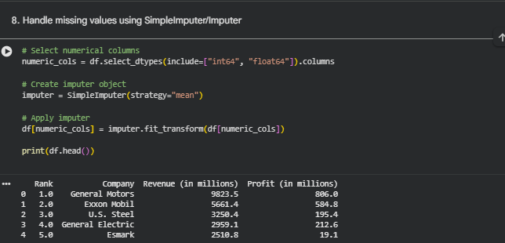
Manage Inappropriate Feature Data Type
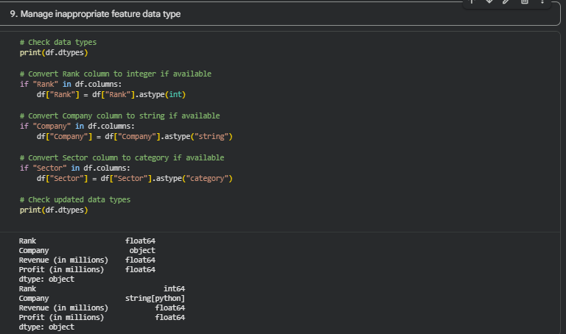
Performing Feature Vector Scaling
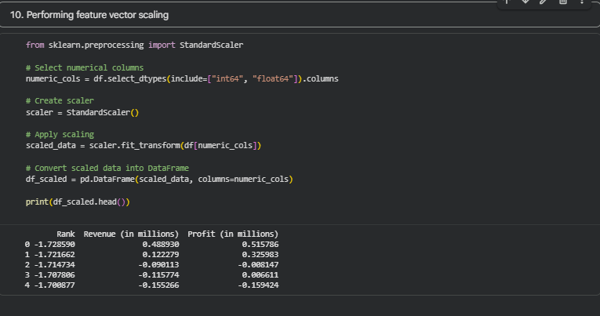
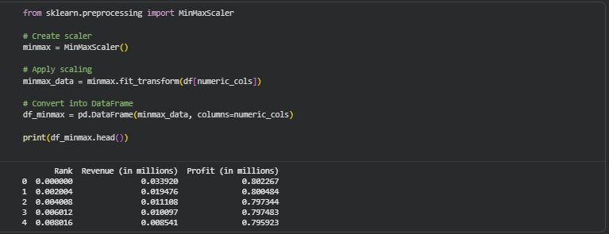
Lab Task

Example 1: Mean Strategy
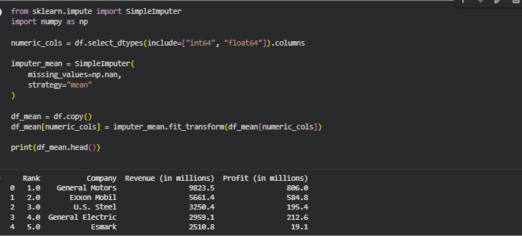

Example 2: Median Strategy
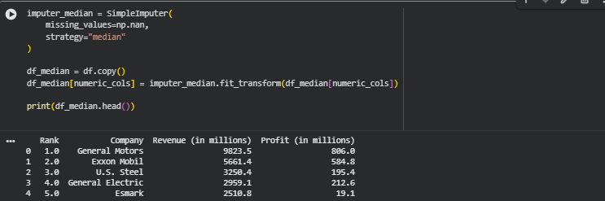

Example 3: Most Frequent Strategy
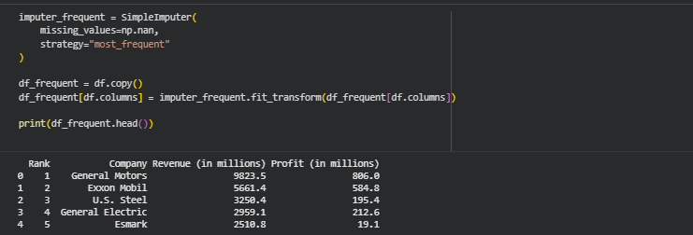

Example 4: Constant Strategy
